Paddle Bala
Saturday 23 August
The team completing the 3 Lakes / 3 Peaks Challenge will end their expedition by Paddling the length (and back) of Bala Lake on Saturday 22 Aug. Come and join them for this 7 mile challenge.
Meet at the Club house 08.00 to travel to Bala with boats and start the final stage of the challenge at 10.30
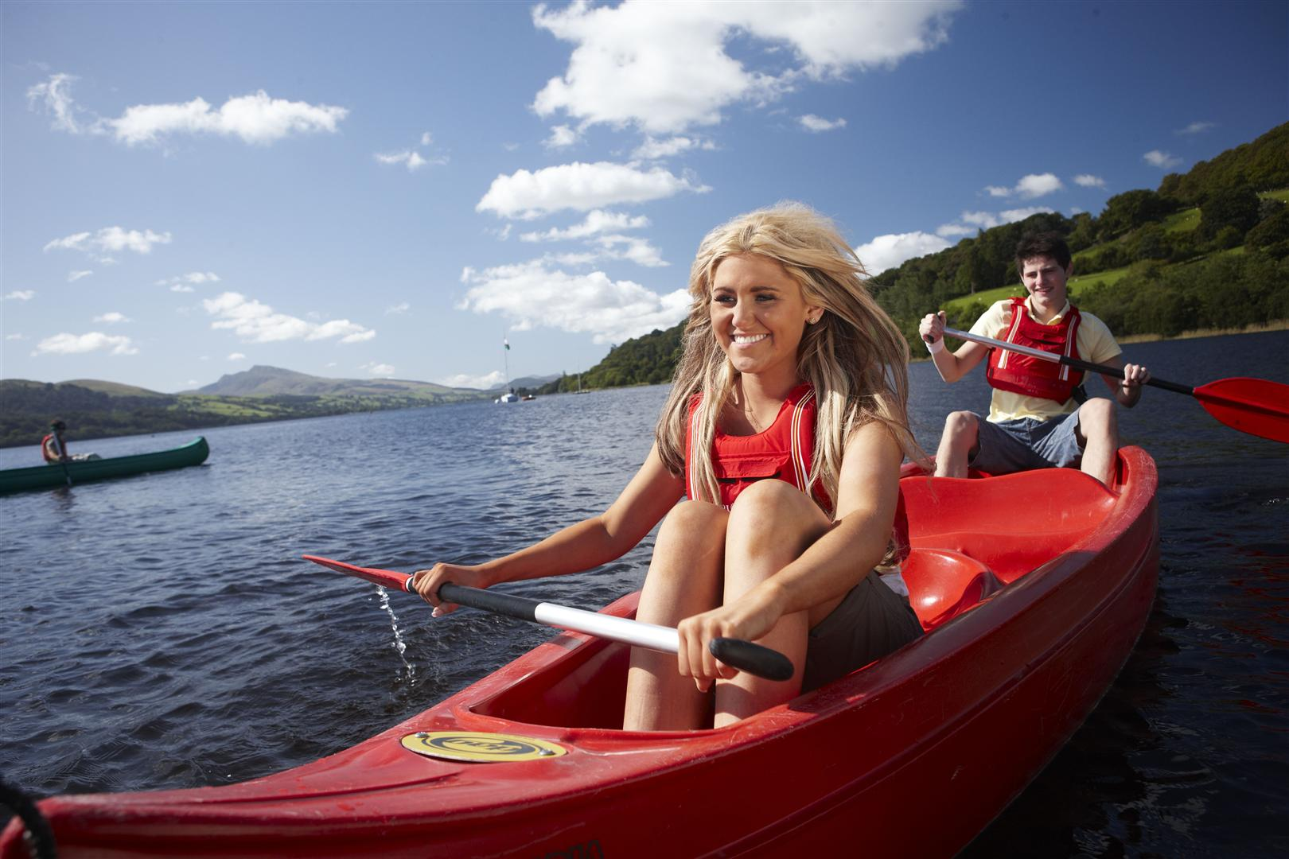
If you intend coming can you add your names below and indicate if you have your own boat or would like to use a club canoe / kayak and if you are prepared to drive and carry boats.
Name | Car driver with roof rack | Own boat | Club kayak | Club canoe

