Sunday 20th March
River Dove Trip
Organised by Burton Canoe Club
11 miles near Burton on Trent this is an organised event by Burton Canoe Club. Grade 1-2 water (easy), 3 weirs (all are easily portable).
Mutual friends trip, some safety provided by organisers.
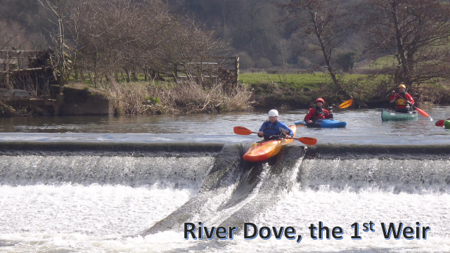

Sunday 17th April
River Vyrnwy. Meifod to Llanymynech

A local river trip on easy moving water. A distance of 12.5 miles. Suitable for confident flat water paddlers who want to try a local River.

‘Mutual Friends Trip’
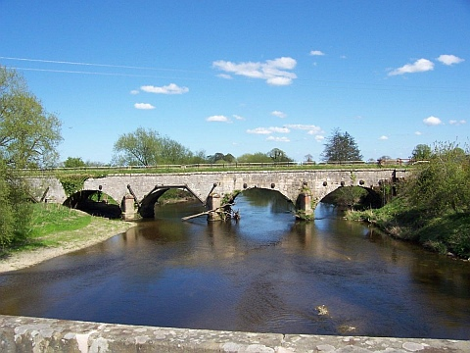

Sunday 8th May
Cardiff White Water Centre
An opportunity to experience the white water course, either taking your own kayak, or hire an inflatable ‘hot dog’ as below.
Club trip, hot dogs suitable for anyone who can swim confidently.

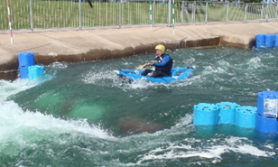
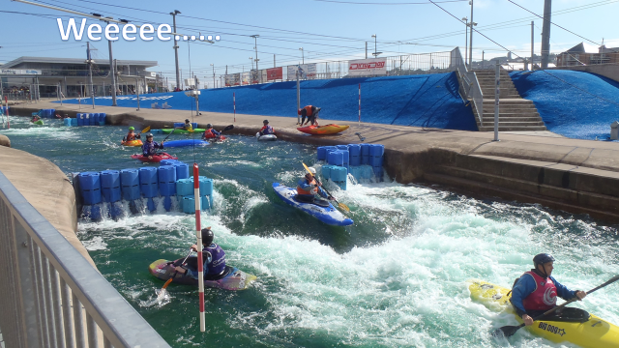

Saturday 25th June
Mawddach Paddlesport Festival
20km Mawddach Marathon
Tidally assisted Ascent & Descent of the Mawddach Estuary from Barmouth to Penmaenpool & back with a "Le Mans" start. Paddlers may enter in any type of Canoe or Kayak and can expect this Marathon to take 1-1½hrs to complete.
This is an ideal way to race and enjoy the magnificent surroundings of The Mawddach Estuary and the splendour of the Southern Snowdonia Mountains.

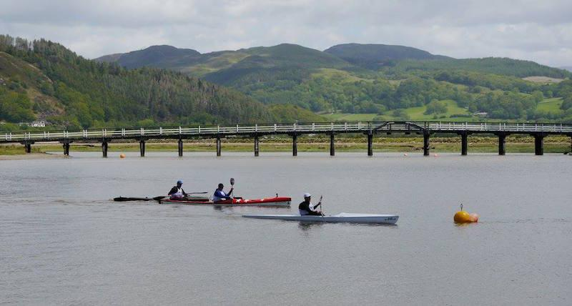

Sunday 26th June
Mawddach Paddlesport Festival
The Mawddach Challenge 6km Raft Race
For Teams of 6 Paddlers. Raced in 2xCanadian Open Canoes, rafted together with a rigid Pole NO SAILS
The Race is around a part of the Estuary just above Barmouth Bridge, is about 45mins in duration, and starts and finishes in Barmouth Harbour in front of the Home Crowd. Fancy Dress is encouraged!
Come for both days and spend a weekend at the Seaside
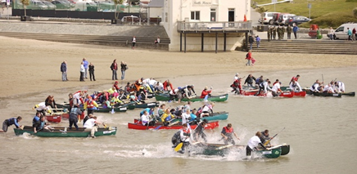

Sunday 10th July
Doggy Paddle
Organised by Leamington Spa Canoe Club May 2015
18 miles of easy moving water, Warwick to Stratford upon Avon. 3 portages (weirs) fantastic scenery through the ground of Warwick Castle. Mutual friends trip, some safety provided by organisers.
A brilliant day out for open boats and new paddlers.

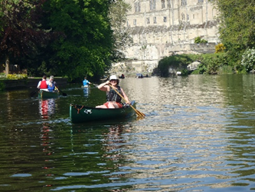

30th / 31st July
Wye Summer Weekend Camping
Bycross Farm to Hoarwithy
Continuing last year’s trip we will paddle a further 25 miles over two days towards the sea. Camping overnight on Saturday. Grade 1 moving water, suitable for a first river trip. ‘Mutual Friends Trip’
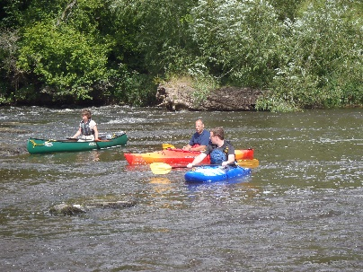

13th to 21st August
The Big One
Coast to Coast along Loch Ness and the Caledonian Canal.
A week’s trip, paddling and camping across Scotland. The Great Glen Canoe Trail follows the 60 miles of the Caledonian Canal from Corpach (Fort William) in the West to Clachnaharry (Inverness) in the East.
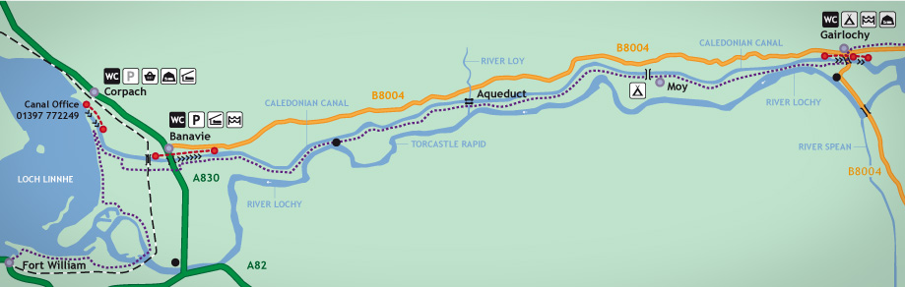
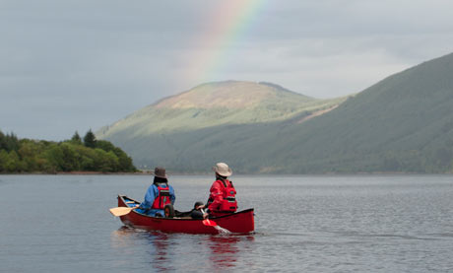

Saturday 10th September
Karan Porter Memorial Trip
In memory of a former member of the Club, we will paddle the canal from Ellesmere back to the Club House, ending with a social lunch.
Suitable for all paddlers

Sunday 25th September
Llangollen to Chirk Bank
This is a 10 mile trip through magnificent scenery which includes two aqueducts (the Pontcysyllte Aqueduct is one of the wonders of the canal system) and two tunnels (Whitehouses Tunnel is 191 yards long and Chirk Tunnel is 459 yards). Club trip and the last of the year.
