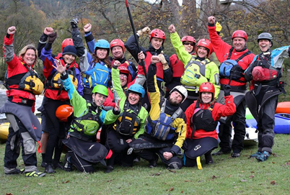
‘NEWS SPLASH’

ISSUE: March 2018

Welcome to our new look Shropshire Paddlesport Monthly Club Newsletter! Our Monthly Newsletter will be coming out at the beginning of each month. It will include latest club news, information on club events, trips, extra sessions, members items for sale or swap, Paddle2Nature and junior paddlers section. If any club members wish to contribute, all contributions to our club newsletter are welcome.
Paddle2Nature
Friday 2nd March - Adoption meeting, with Jason Watts from CRT – Unfortunately cancelled due to the bad weather.
Wednesday 7th March = Curlew survey meeting at Morda Social Club 7.30 start

Saturday 31st arch = Annual Litter pick and Easter Egg Hunt
Club News….
- Oswestry Sports Forum recently awarded the Club a £500 grant for the purchase of a ‘ladies white water kayak’ and equipment.
- The Club is organising an Open Day to welcome to new paddlers to Shropshire Paddlesport on Saturday the 5th May 10am to 3pm. Activities to include: tester sessions on different craft, demonstrations, time trials/races and games, paddle to nature, catering, a great fun day! Lots of Volunteers needed so if you can help, please speak to Liz Loader who is co-ordinating the day.
- The ‘Big One’ week-long trip to Norfolk dates Saturday August 11th until Sunday August 19th. Further information to follow. If you are interested but didn’t get chance to come to the planning meeting, speak to Bill or Sian Norris.

- The Club will arrange the following courses: Paddlesport Leader (7 members interested), Instructor (6 members interested), Foundations Safety and Rescue (4 members interested), White Water Safety and Rescue (7 members interested) dates and cost to follow.
Easter Saturday 31st March, come and help with the annual litter pick on and along the Canal and join in the Easter Egg Hunt! Normal Saturday 9am start, come and join in the fun!
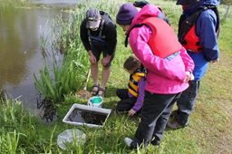

The British Canoeing 2 Star Award
The 2 Star Award is an improvement award which supports the development of fundamental paddlesport skills on sheltered water. It recognises a paddler’s understanding of how the paddle, boat and water interact and their ability to control movement of both canoes and kayaks using fundamental skills.
Pre-requisites
Candidates must be able to swim 25 metres wearing a buoyancy aid and have experience of:
Paddling two different craft – surf kayak, closed cockpit kayak, open cockpit kayak, closed cockpit canoe, solo/tandem open canoe, racing boat, wave‐ski, flat‐hulled boat, v‐shaped hull, slalom boat, polo boat, or sea kayak
Paddling in two different locations – canal, river, loch/lake, or sea. Different parts of large bodies of water can be counted as two different locations, Competing in two paddlesport competitions – club level event, slalom, polo, sprint, freestyle bell‐boat etc. OR completing two journeys of approx. two hours duration
Shropshire Paddlesport has now developed a Personal 2 Star Skills Record booklet for club members to use and to complete their learning of new skills for this award at their own pace and under the guidance from the club coaches.
For further information on the 2 Star award please speak to one of the Club coaches or check out the British Canoeing Website britishcanoeing.org.uk
CLUB DIARY DATES
pool sessions
February 10th March – 4-6 places fully booked.
club committee meeting thurs 8th march 7.30pm, all welcome
Sunday 18th march – River dove trip. organised byburton canoe club. suitable for 2 star capability11 miles including 3 weirs (all portable)
sunday 25th march – atcham to ironbridge, 15 miles of easy paddling down river severn. suitable for first river trip.
Litter pick and easter egg hunt – saturday 31st march, all welcome
SUNDAY 8TH APRIL – Montford Bridge to Frankwell. Approximately 12 MILES. SUITABLE FIRST RIVER TRIP.

To contribute to ‘News Splash’, be it articles, news, for sale or swap or article suggestions - please send to Claire at spsclubnewsletter24@gmail.com All contributions welcome
Painting party – help needed to paint the stairwell and both entrance lobby’s in the Club House, the evenings of 19th,20th and 21st March.
This Photo by Unknown Author is licensed under CC BY
Montgomery Canal Triathlon – 19th May. As a club we help out with the Triathlon, helping to portage competitor’s boats. Volunteers needed please.

Junior Paddlers
Junior members are encouraged to take part in the BCU Paddlepower scheme which helps to develop their skills whilst ‘messing about in boats!’ If any junior paddlers are interested speak to the Club coaches.
Join in fun activities such as raft building, games with kayaks and canoes and seeing how fast you can go in different boats with time trials

